**Week 3 – Homework Exercise 1**

Based on your investigation of the data and your assignment (analyze salaries to determine employees who can be promoted), you need to make some changes to data items in the **EMPLOYEES** table.

1. **Working with Data Items**
   1. Open the browser and sign into Visual Analytics using your student credentials.
   2. Open the **VA1- Practice3.1 report from the** **SAS Content ⇨ Courses ⇨ YVA185 ⇨ Basics ⇨ Practices (HR) folder.**
   3. View the data items in the Data pane (hint: you may need to click the pencil icon in the upper left to view the Data pane) and answer the following questions:

What is the classification of **Employee ID**? **Manager at 1. level**?

**Answer**: Employee ID is Category, and Manager at 1. Level is measure.

What does the **Frequency** data item represent?

**Answer**: Frequency is representing the number of employees

* 1. Change the classification for **Manager at 1. level** to **Category**.
  2. Change the format for **Annual Salary** to **Dollar13.2**.
  3. Rename the following data items:

|  |  |
| --- | --- |
| **Old name** | **New name** |
| **Employee ID** | **ID** |
| **Employee Name** | **Name** |
| **Manager at 1. level** | **Manager ID** |
| **Frequency** | Number of Employees |

**Note:** Click  (**Actions**) and select **Refresh data source** at the top of the Data pane to collapse the data item properties.

* 1. Save the report.
  2. Sign out of Visual Analytics.

End of Exercise

**Week 3 – Homework Exercise 2**

For the Human Resources team, you have been asked to analyze salaries to determine which employees could be eligible for promotion. As a first step, you would like to understand the range of salaries at Orion Star, as well as total salaries by job title.  
  
You will then use this analysis to determine the employees targeted for promotion.

1. **Exploring Data: Part 1**
   1. Open the browser and sign into Visual Analytics using your student credentials.
   2. Open the **VA1- Practice3.2a** report from the **SAS Content ⇨ Courses ⇨ YVA185 ⇨ Basics ⇨ Practices (HR) folder.** Ensure you are in the editing report view mode.
   3. Create an automatic chart using the following data items:

**Annual Salary**

**Frequency Percent**

The automatic chart should resemble the following:

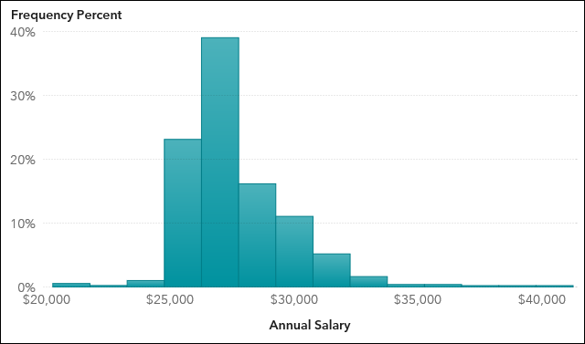

* 1. Modify the following options for the automatic chart:

|  |  |
| --- | --- |
| **Name** | Distribution of Salary |
| **Bin range** | Measure values |
| **Set a fixed bin count** | <selected> |
| **Bin count** | 4 |

* 1. Maximize the histogram to answer the following question:

Into which range do a majority of salaries fall?

**Answer**: 77.59% is the majority of salaries and it is between $25,815 ~ $30,795

* 1. Add a bar chart on the right of the automatic chart by assigning the following data items to the specified roles:

|  |  |
| --- | --- |
| **Category** | **Job Title** |
| **Measure** | **Annual Salary** |
| **Group** | **Department** |

* 1. Specify **Total Salary by Job and Department** as the name of the bar chart.

The bar chart should resemble the following:

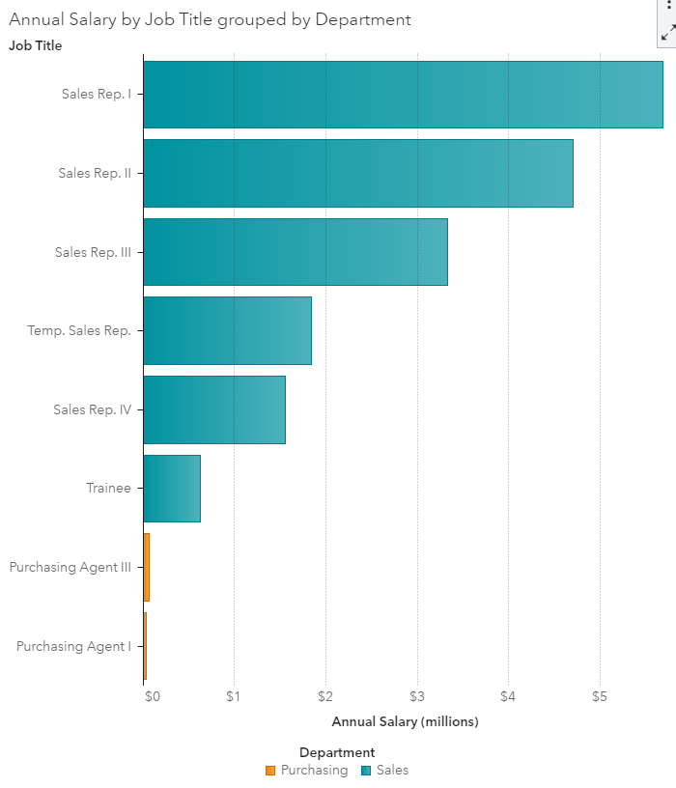

* 1. Answer the following questions:

In which department are a majority of our salary costs spent? For which job title?

**Answer**: most of cost were spent in Sales Departments. the majority that was spent for Sales Rep. 1 as Job title.

Why do you think salary costs are so much higher for this group?

**Answer**: I think, it is because a lot of employees were in Sale group compared to Purchasing Group. That is why the annual salary of Sales Department is higher than Purchasing Department and Sales departments were separated in many other groups that specified within detail. For example, Sales Rep are divided in 4 groups, temp sales rep, and trainee.

The final report should resemble the following:

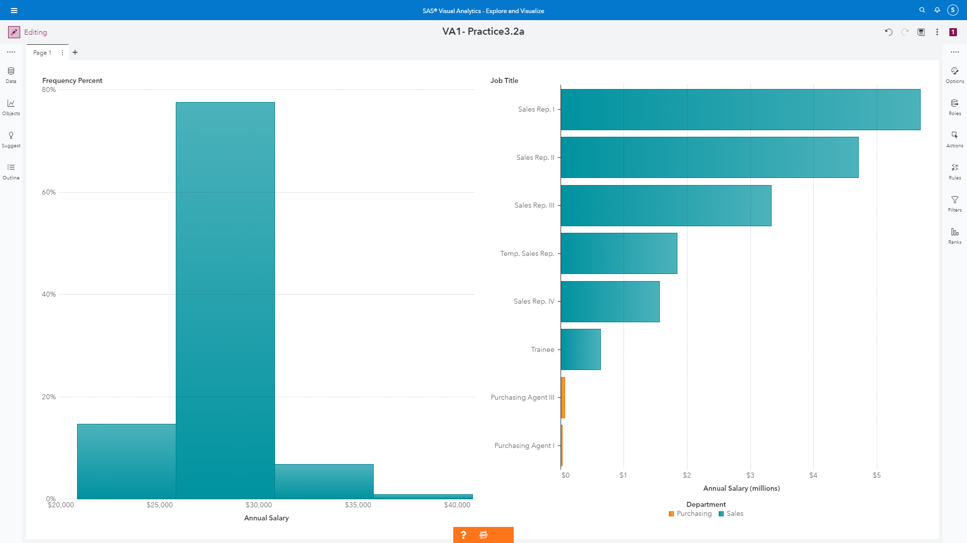

* 1. Save the report.
  2. Sign out of Visual Analytics.

End of Exercise

**Week 3 – Homework Exercise 3**

In the previous analysis, you discovered that salary costs were higher for employees with the Sales Rep. I title. Continue to analyze salary costs by job title to determine employees that might qualify for promotion.

1. **Exploring Data: Part 2**
   1. Open the browser and sign in to Visual Analytics using your student credentials.
   2. Open the **VA1- Practice3.2b report from the SAS Content** ⇨ **Courses** ⇨ **YVA185** ⇨ **Basics** ⇨ **Practices (HR) folder.** Ensure you are in the editing report view mode.
   3. On Page 2, create a box plot by assigning the following data items to the specified roles:

|  |  |
| --- | --- |
| **Category** | **Job Title** |
| **Measures** | **Annual Salary** |

* 1. Modify the following options for the box plot:

|  |  |
| --- | --- |
| **Name** | **Salary Analysis by Job Title** |
| **Outliers** | Show Outliers |
| **Show averages** | <selected> |

The box plot should resemble the following:

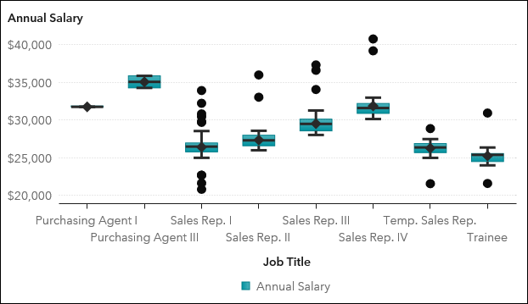

* 1. Maximize the box plot to answer the following questions:

Which job title has the highest average salary? The lowest?

**Answer**: Purchasing Agent III has the highest average salary and Trainee has the lowest average salary

For the job title Sales Rep. I, what is the highest annual salary amount being paid to an employee?

**Answer**: For Sales Rep. 1 highest annual salary is 33,925

Hint: After answering the question, click  (**Restore**) in the upper right corner.

* 1. Save the report.
  2. Sign out of Visual Analytics.

End of Exercise

**Week 3 – Homework Exercise 4**

In the previous analysis, you discovered higher salary costs for employees with the Sales Rep. I title despite having relatively low average salary costs. Why are total salary costs higher for this group?  
  
In addition to the analysis of salaries by job title, you also need to analyze the type of employee (active versus retired) and years of service to determine which employees to target for the next round of promotions.

1. **Creating Data Items**
   1. Open the browser and sign in to Visual Analytics using your student credentials.
   2. Open the **VA1- Practice3.3a report from the SAS Content** ⇨ **Courses** ⇨ **YVA185** ⇨ **Basics** ⇨ **Practices (HR) folder.** Ensure you are in the editing report view mode.
   3. Create a new data item, **Employee Status**, by assigning the following labels to the values:

|  |  |
| --- | --- |
| **Employee Status (label)** | **Employee Termination Date (value)** |
| Active | . |
| Retired | <all remaining values> |

* 1. On Page 3, create a bar chart by assigning the following data items to the specified roles:

|  |  |
| --- | --- |
| **Category** | **Job Title** |
| **Measure** | **Years of Service** |
| **Group** | **Employee Status** |

* 1. Specify **Years of Service by Job Title and Status** as the name of the bar chart.
  2. Change the aggregation for **Years of Service** to **Average**.

The bar chart should resemble the following:

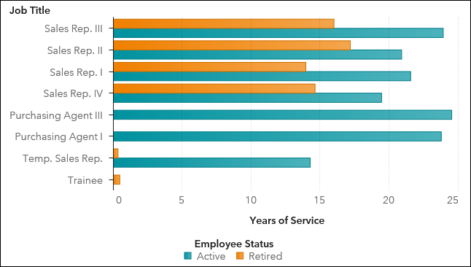

* 1. Answer the following question:

Management has decided that one possible criterion for promotion is years of service. Considering this, with which Sales Rep job title would you recommend starting the promotion analysis?

**Answer**: I want to recommend Sales Rep. III because job title of rep III had highest Years of Service and compared with Active Years of Service, it has low retired Years of Service. So I want to recommend Sales Rep III.

* 1. Save the report.
  2. Sign out of Visual Analytics.

End of Exercise

**Week 3 – Homework Exercise 5**

Management has decided that your initial promotion analysis should focus on active employees in the Sales Department.

The amount of profit generated by each employee has been identified as one possible criterion for promotion. Given this criterion, you need to identify locations where initial promotions should begin.

1. **Applying Filters**
   1. Open the browser and sign in to Visual Analytics using your student credentials.
   2. Open the **VA1- Practice3.3b report from the SAS Content** ⇨ **Courses** ⇨ **YVA185** ⇨ **Basics** ⇨ **Practices (HR) folder**. Ensure you are in the editing report view mode.
   3. Add a data source filter to filter for active employees in the Sales Department.sa

**Note:** Use the AND operator (in the Boolean group) to filter for multiple conditions. After the data source filter is applied, 429 observations should be returned.

* 1. Change the classification for **Employee Country** to **Geography** ⇨ **Country or Region ISO 2-Letter Codes**.
  2. On Page 4, create a geo coordinate map by assigning the following data items to the specified roles:

|  |  |
| --- | --- |
| **Category** | **Employee Country** |
| **Size** | **Total Profit** |
| **Color** | **Number of Employees** |

The geo coordinate map should resemble the following:

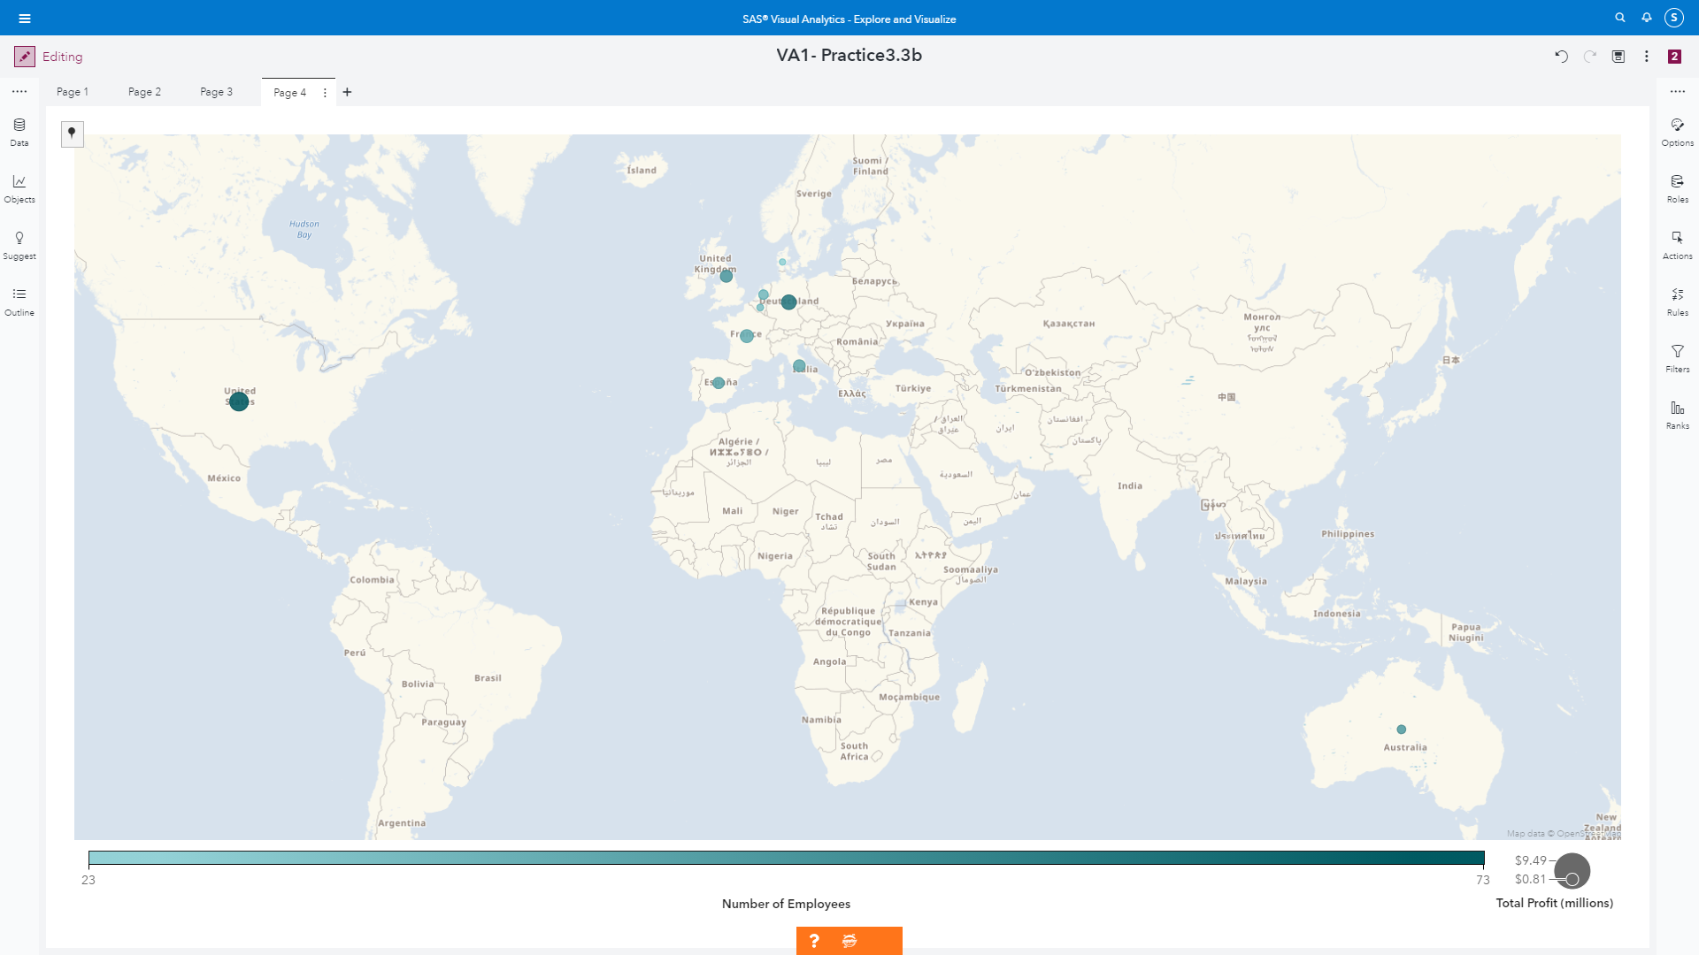

* 1. Maximize the geo map to answer the following questions:

Management has decided that one possible criterion for promotion is profit generated. Which two countries generate the highest profit? Why do they have such high profits?

**Answer**: US (has total profit of $9,490,871.30) and DE (has total profit of $6,705,983.90). Because these two has the highest Number of Employees too.

Hint: After answering the questions, click  (**Restore**) in the upper right corner.

* 1. In the geo map, specify **Average Profit** for the Size role.
  2. Specify **Average Profit and Number of Employees by Country** as the name of the geo map.

The updated geo map should resemble the following:

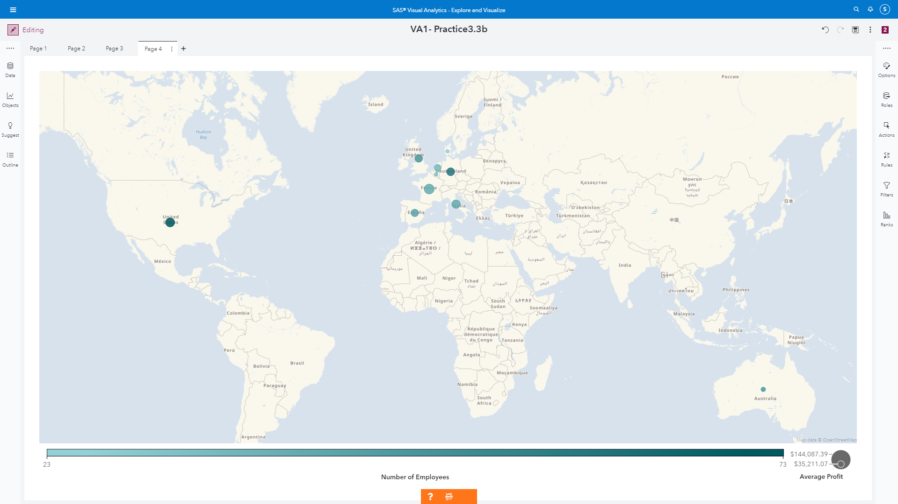

* 1. Maximize the geo map to answer the following question:

With which country would you recommend starting promotions if profit generated is one possible criterion for promotion?

**Answer**: I want to starting promotion from US. Although US does not rank the highest average profit but they ranked the highest number of employee. In fact, Although US is not number one in Average profit, US ranked second highest at Average profit. Unlike US, FR is the highest average profit but ranked 4th lowest for number of Employees. Therefore I want to start promotion from US.

Hint: After answering the question, click  (**Restore**) in the upper right corner.

* 1. Save the report.
  2. Sign out of Visual Analytics.